Dear Parents and Senior Players,
Thank you for all your support last season, it was once again a successful year of hockey with all ages enjoying both fun training sessions, junior tournaments and competitive matches.
We are now ready to start re-registration for the 2019-20 season so please ALL read the following information.
We are aware that not all members are correctly registered on the website. Some have not completed all the information (including emergency contact information), some are not set up to receive emails and some parents have only registered their child and not themselves as a parent.
ALL PARENTS OF JUNIOR PLAYERS ie anyone aged U18 at the start of the season: Please when you re-register can you make sure a parent is personally registered on Pitchero – that you have an email address on your account and that you have activated it when you receive the email request to do so! We will assign payments for the annual junior membership fees over the next few weeks so please ensure that you keep an eye out on your Pitchero app / website account /email for notification.
No junior registrations will be accepted without a parental account and ALSO without the following information being updated
- Childs Date of Birth
- Childs correct school year from September 2019
- Childs medical information
- Season changed to 2019-20
- Code of Conduct – read and ticked
- Photo/video acceptance – read and ticked

To complete the information please go to: -
Pitchero login top right of computer screen
Once logged in go to top right and click on your picture/name
Click – your account

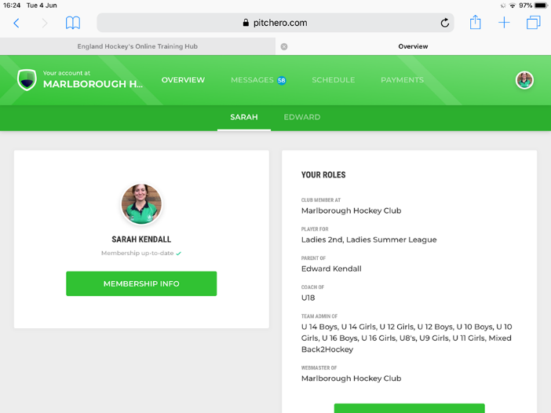
You will see your name and your child’s/children’s in the dark green bar. Click on names to go to each member. Go to membership info for yourself and all junior members and update any incomplete areas or changes.
ALL SENIOR members – please update your info ASAP especially emergency contact details and medical information and the playing season.
ALL MEMBERS: There is a Pitchero Club App. – please do download it to receive up to date info and match information.
NOT RE-REGISTERING THIS SEASON - If you, or your child/ren, will not be re-registering with us this year please let either myself or Sarah know so that we can remove you from the system!
If you have any queries, please let us know.

Many thanks
Karen Jones MHC Junior Membership Secretary (email: juniors.mhc@gmail.com)
Sarah Kendall MHC Chair

